IRA non-deductible contributions are made when a deductible contribution is limited by income and/or the taxpayer having a retirement plan. When non-deductible contributions are made, they are tracked on form 8606. When a distribution is taken from an IRA that has had non-deductible contribution, the non-taxable portion of the distribution is calculated on form 8606.

Non-deductible contributions can be made up to the maximum allowable IRA contribution. For tax year 2016, the maximum allowable contribution is $5,500($6,500 if taxpayer is 50 or older yrs of age). The total of all IRA contibutions (deductible, non-deductible and Roth) can not exceed the maximum allowable contribution.

References:
- Instructions for Form 8606
- IRS Pub 4012 Tab D-25 (AARP modified version link from TP4F Preparer Page)
- IRS Pub 590A

Form 8606 Description
- Part I – For reporting non-deductible contributions as well as distributions
    - Distributions reported here only if there were non-deductible contributions
- Part II – Conversions from traditional IRAs to Roth IRAs– Out-Of-Scope
- Part III – Non-qualified distributions from Roth IRAs – Out of Scope unless it is an error and it is a qualified distribution

Reporting Non-Deductible Contributions
- Non-Deductible contributions MUST be reported on Form 8606 Part I
  - Creates a basis for IRA Withdrawals
  - If non-deductible contributions are not reported on the 8606, there is no tax-free benefit on the distribution
- Form 8606 provides cumulative record
  - Non-Deductible Contributions (cost basis) for distributions

Non-Deductible Contributions entered in TaxSlayer (See example for details)
- Enter all IRA contributions (deductible and non-deductible) in Adjustments – IRA Deductions
- Enter non-dedectible contributions in Adjustments - Nondeductible IRAs Form 8606
- Taxpayer must provide amount of the basis for earlier years

IRA Distributions after Previous Years of Non-deductible Contributions (See example for details)
- If there has been non-deductible contribution(s) to an IRA, a portion of the distribution shown on a 1099-R is not taxable.
  - The taxpayer must have the 8606. If non-deductible distributions were taken in the previous year, the 8606 should be part of that return.
  - Complete the 1099-R as you normally would
  - Enter form 8606 in the TaxSlayer search box
  - Complete the 8606 input as shown below
  - Go to “Preview Return” and note the amounts in box 13 and box 15 of form 8606
  - Enter the taxable portion in the 1099-R box 2a
  - Enter the amount on the Form 8606 box 13 in the NJ Checklist as adjustments to NJ 1040 box 19b

Example of entering IRA Distributions after previous years of Non-deductible Contributions in TaxSlayer.

A taxpayer is 61 years old. He has taken a $50,000 distribution from an IRA in which he had made $12,500 in non-deductible contributions in previous years. His total of all his IRAs is $450,000. He has not made a contribution to and IRA for 2016.

Step 1 – Enter the 1099-R for the IRA distribution. Leave Box 2 the taxable amount the same as box 1. Complete any other boxes as required from the paper 1099-R. Be sure you check the IRA/SEP/ Simple box” in box 7.

Step 2 – Use the Forms Search Box to go to the form 8606 entry screen.

Step 3 - Enter remaining basis (from prior year Form 8606), year-end value of all IRAs (provided by taxpayer), and the amount of the distribution. If there are any non-deductible contributions for the current tax year, enter them also.

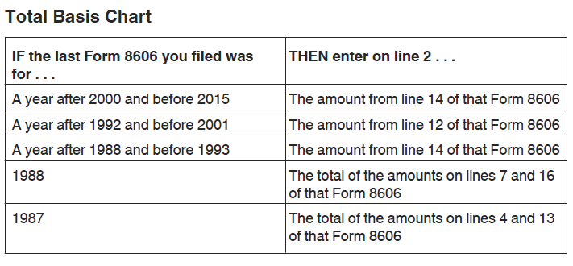

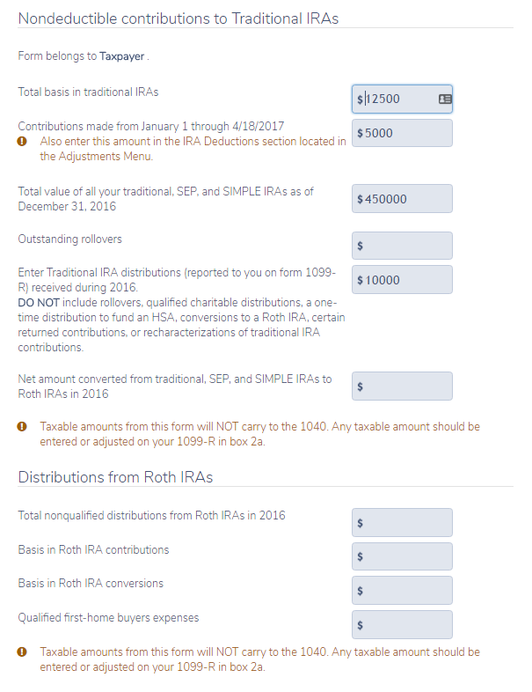
Enter any non-deductible contributions from Jan. 1, 2016 to Apr. 18, 2017. Enter also in Adjustments -IRA Deduction
Enter all IRA distributions received in the current tax year
Enter the total value of all IRAs at the end of the current tax year
Enter basis from previous year’s 8606. See the chart above for the line number on the previous year’s 8606.
Nonqualified distributions from Roth IRAs are OUT OF SCOPE unless it is an error and it is a qualified distribution
Conversions from IRAs to Roth IRAs are OUT OF SCOPE

Step 4 - Preview Return. Look at Form 8606, and find the taxable amount of the distribution on Line 15 and the non-taxable portion on line 13.

Form 8606 from Preview Return
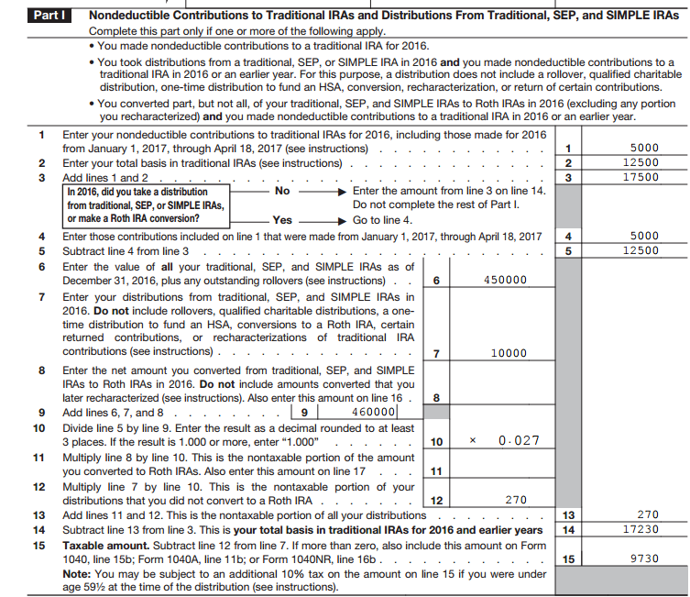
Amount from line 13 to be entered on NJ Checklist as Adjustments to line 19b
Amount from line 15 is to be entered in the 1099-R Box 2a.

Step 5- Go back to the TaxSlayer return. If there is only one IRA distribution, enter the taxable amount (Form 8606 line 15) in Box 2a of the 1099-R. If there is more than one IRA distribution, subtract the nontaxable portion (Form 8606 line 13) from the Box 1 amount on one of the IRAs. Enter the result into Box 2a of that same 1099-R. All the remaining IRAs will be 100% taxable.

Enter the non-taxable portion on the NJ Checklist as Adjustments to line 19b.

A second Form 8606 may be required if each spouse has basis in their IRAs.

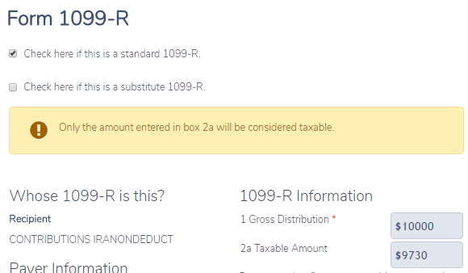

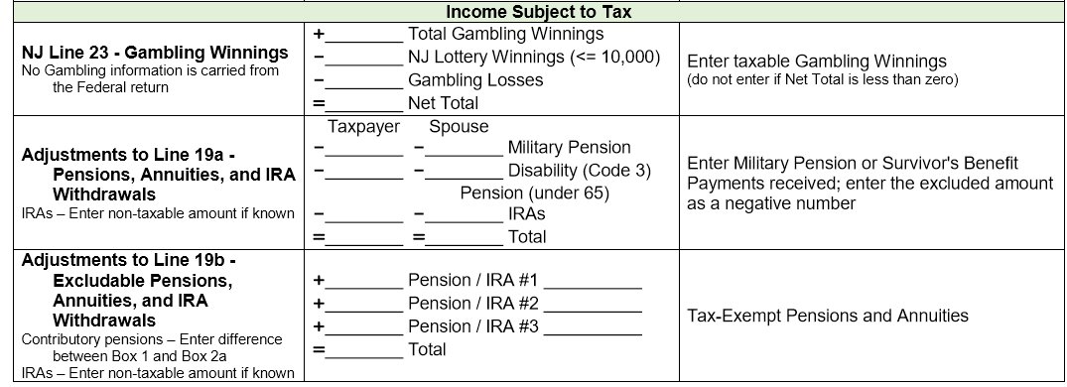
2700

Example of entering Non-deductible contributions in TSO if there are no non-deductible distributions

The same taxpayer as above. He is single. He has W-2 income which includes contributions to a 401K. He wants to contribute to an IRA, but his income and the fact that he has contributed to a 401K prevents him from making a deductable contribution. He decides to make a $5,000 contribution to an IRA as a non-deductable contribution. He has $12,500 of non-deductable contributions from previous years. The value of all of his IRAs as of 12/31/15 is $450,000.00.

Step 1 – In TSO go to Federal – Deductions – Enter myself - Adjustments. Select IRA deduction.

Step 2 – Enter the amount of the IRA deduction the taxpayer wishes to make.

Step 3 – Go to the summary/print tab to determine if the IRA deduction qualifies to be deductable. There should be an amount in 1040 line 32. If the amount entered in Step 2 is on 1040 line 32, you are done.

Step 4 – If there is no value or a different value on 1040 line 32 the IRA contribution does not qualify for a total adjustment IRA deduction.
The taxpayer can make a non-deductible contribution to a traditional IRA or a Roth IRA contribution up to the maximum amount of $5,500 ($6,500 if over 50)

Step 5 – If the taxpayer wants to make a non-deductible contribution to a traditional IRA, go to Adjustments and select the “Nondeductible IRAs Form 8606.

Step 7 – If the taxpayer has a basis of privious year non-deductible contributions, enter in the first line.

Step 8 – Enter the non-deductibel contributions for the current tax year.

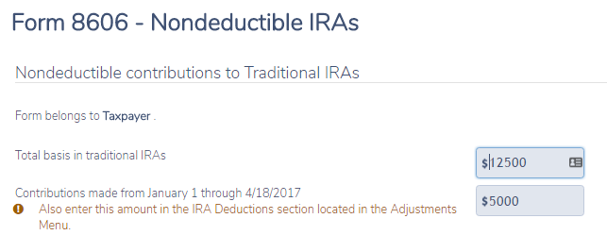
Step 8 – Non-deductible contributions for current year. Also, be sure this amount is entered in Adjustments – IRA Deductions tab.
Step 7 – Basis from previous year. Previous year 8606 line 14

Step 9 - Go to summary/print and confim the 8606 is included and correct

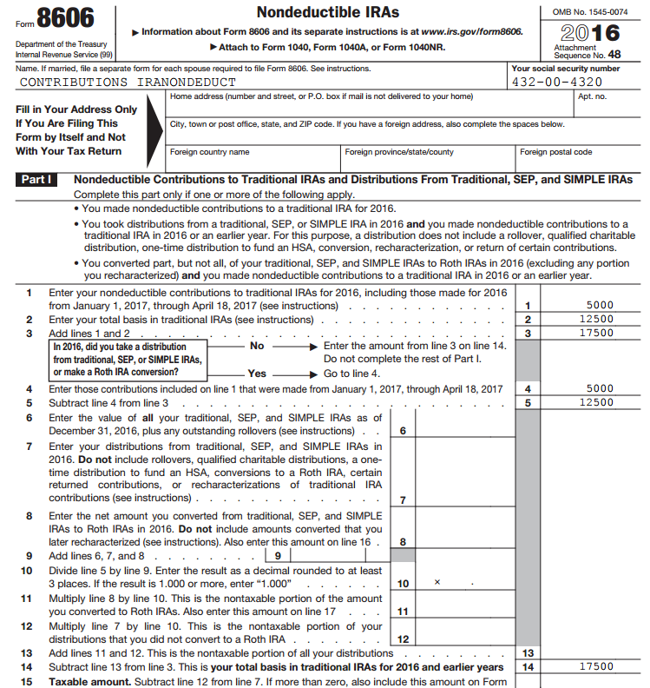
Total amount of basis for future years
Basis from previous years
Non-deductible contribution

